**Assignment 8**

Aim : Set up a Jenkins job that picks up an application from a GitHub repository, builds it, and

runs it and dockerizes the application.

Creating a job in jenkins:

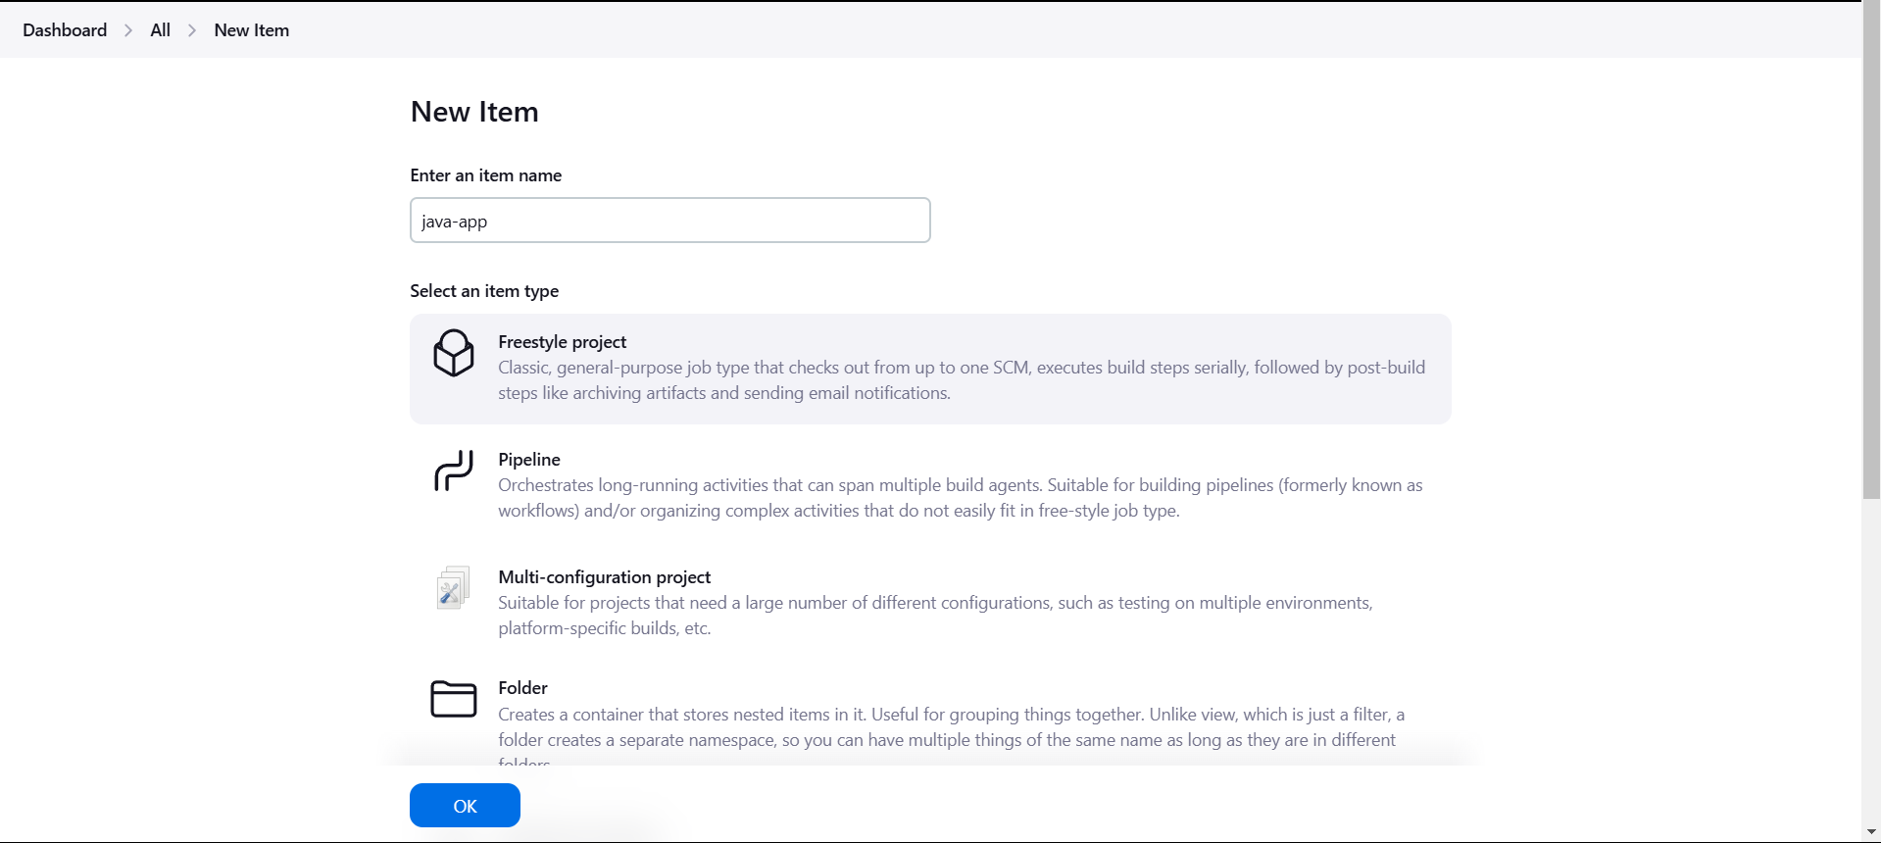

Adding the Git credentials :

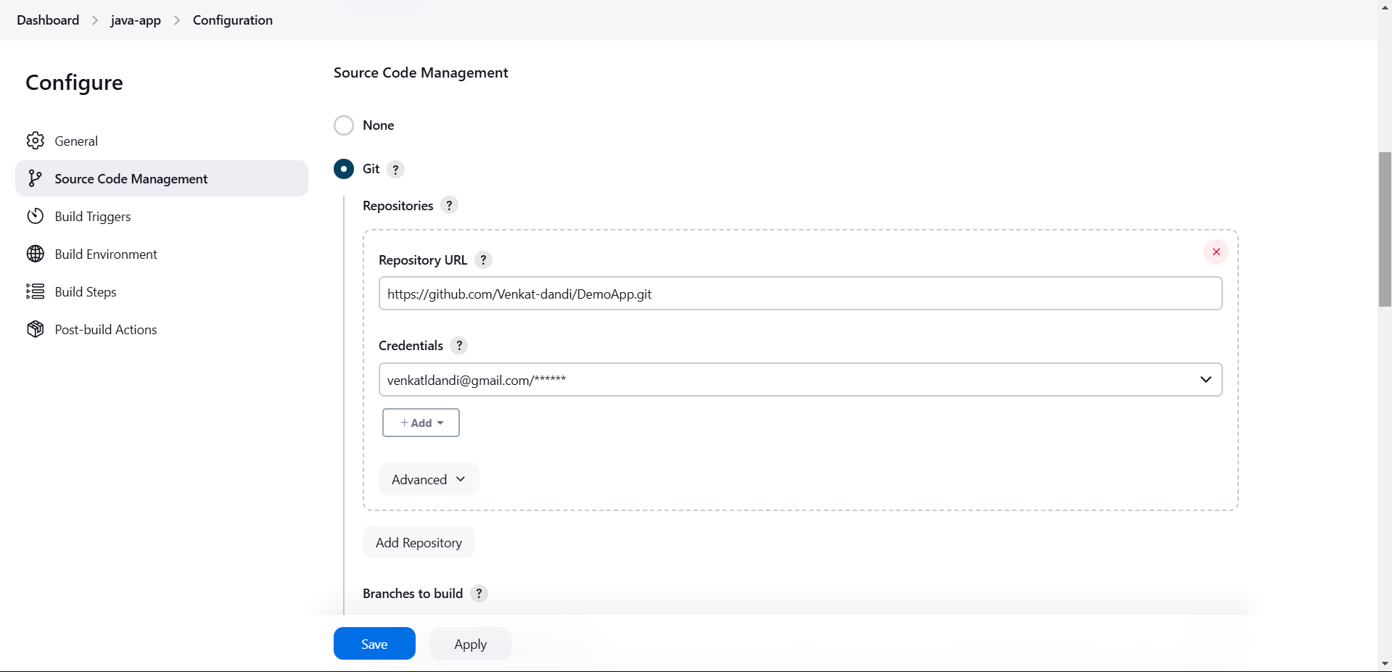

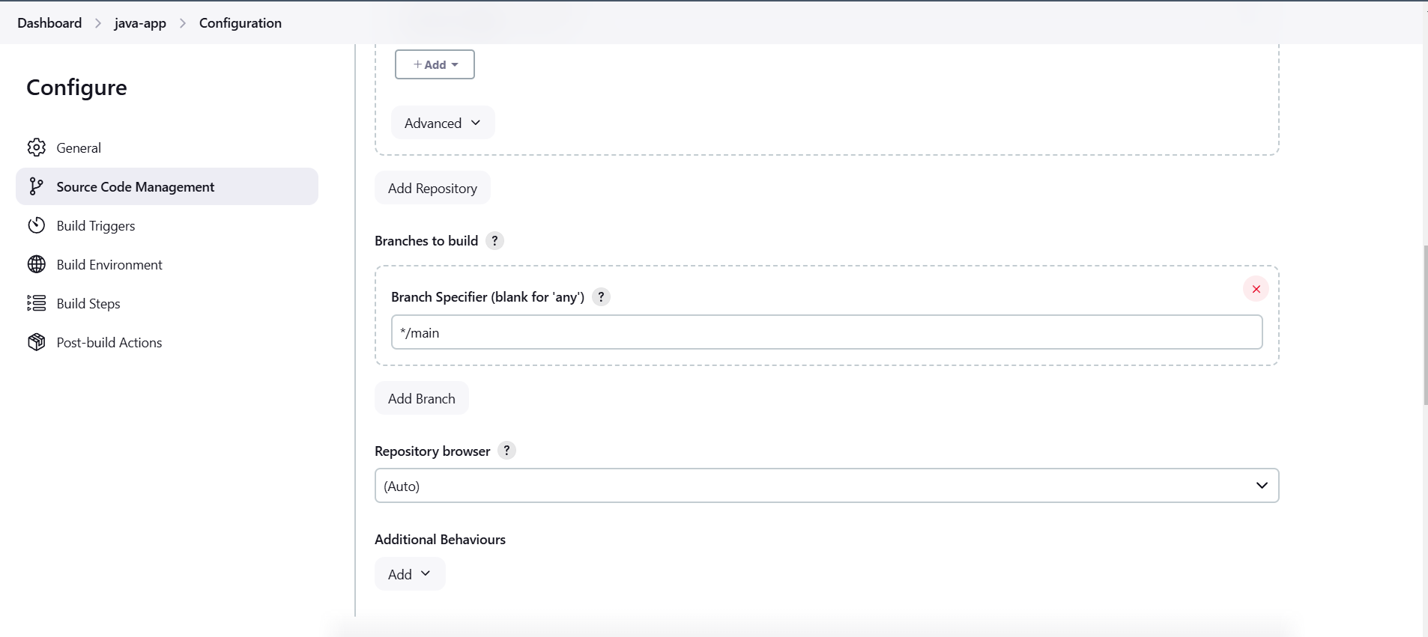

Adding Build Step :

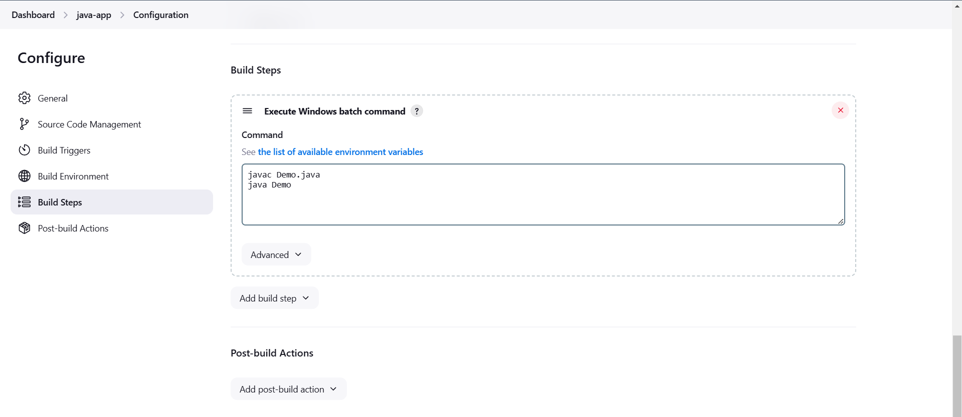

Successfully Built the job:

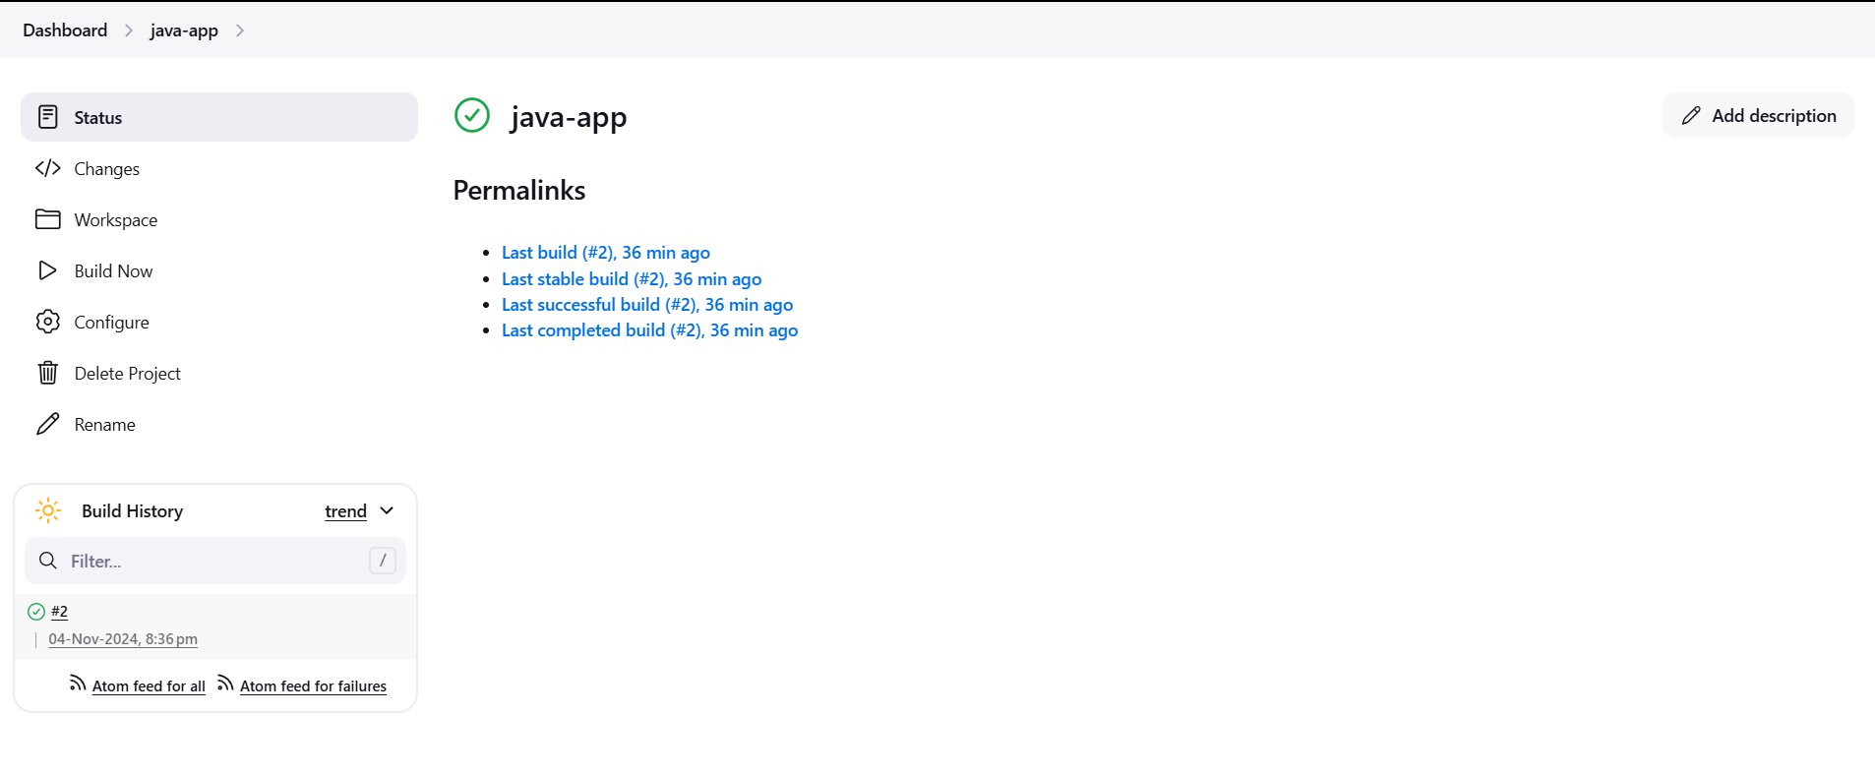

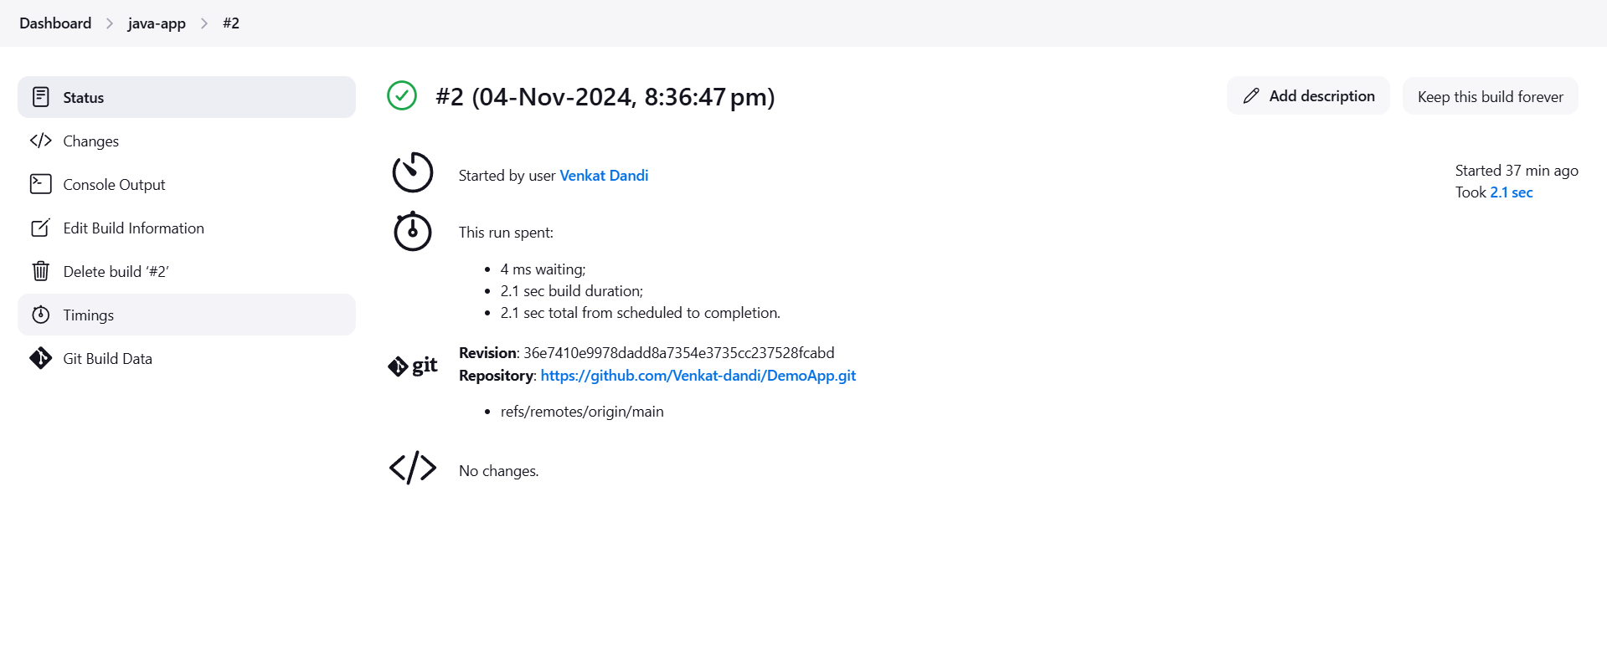

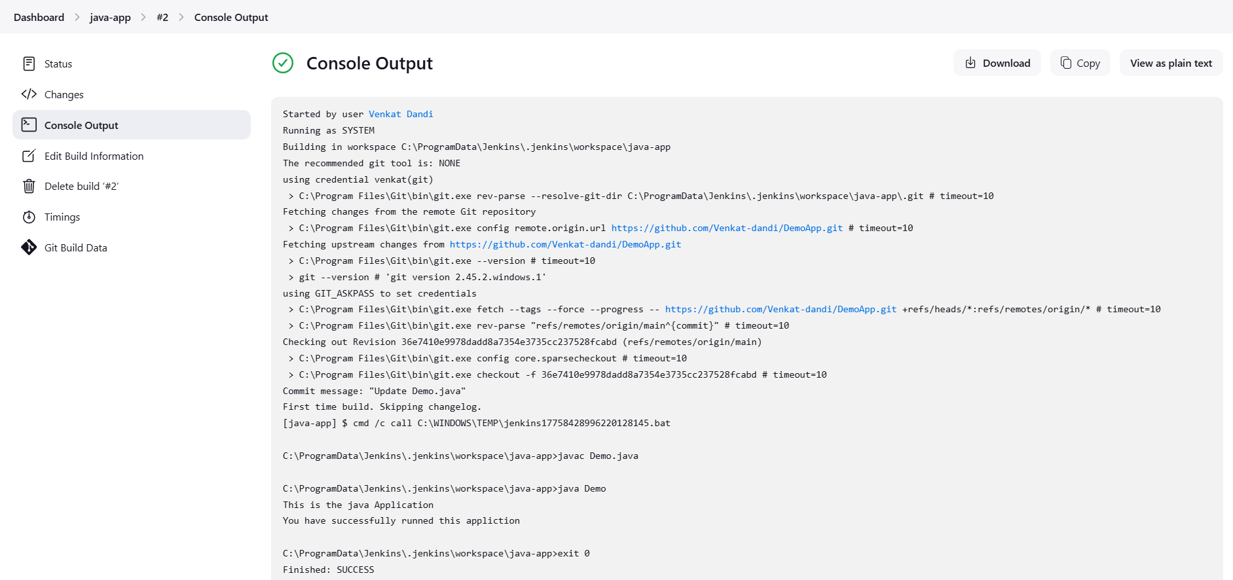

* Building a docker image:

1. Dockerfile:

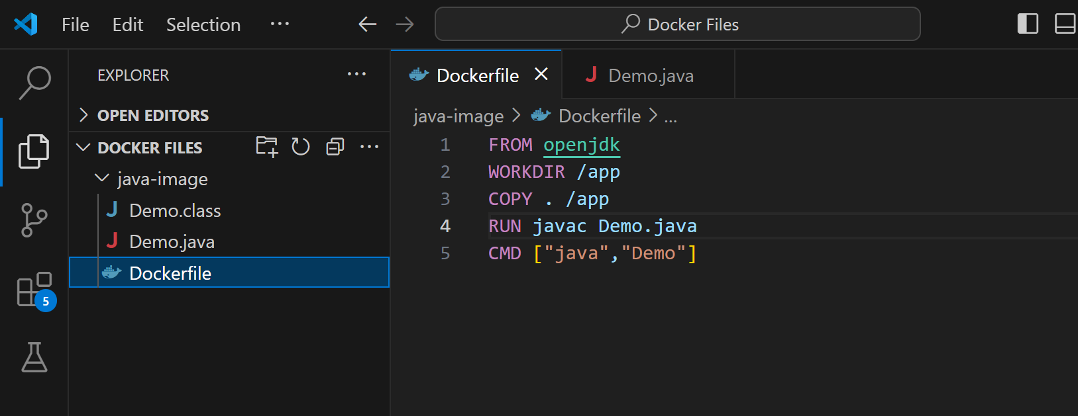

1. Building the docker image:

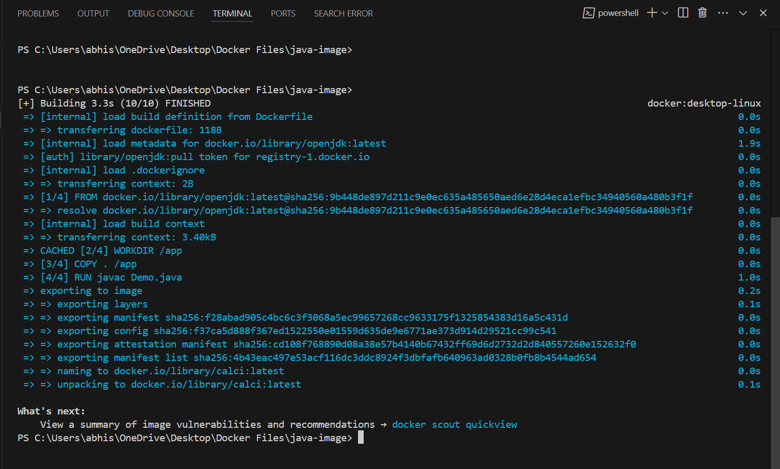

1. Creating a container and running the docker image:

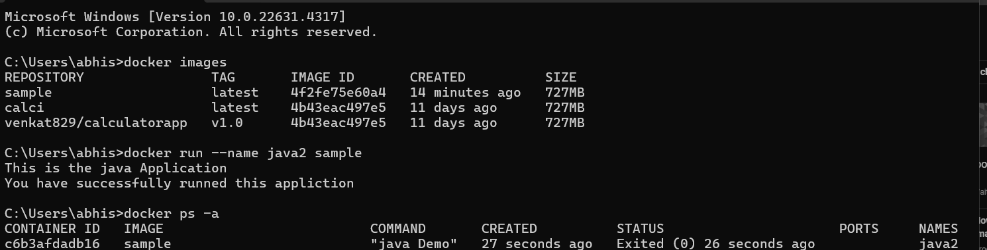

* Pushing docker image to Docker Hub:

1. Logging in and pushing image using “docker push”:

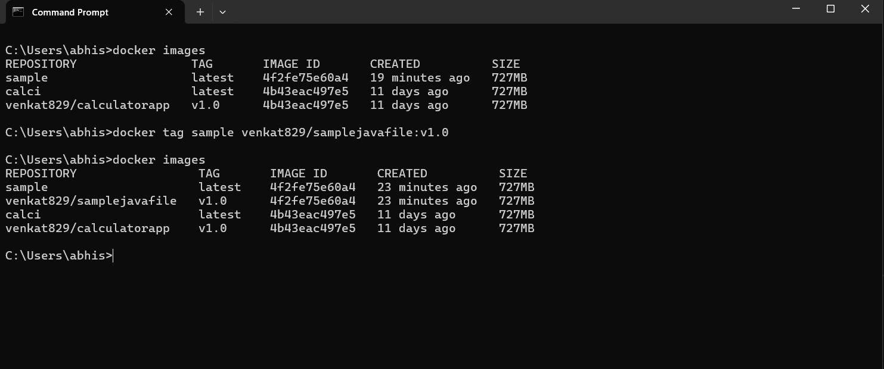

2. Docker Hub screenshots after pushing:

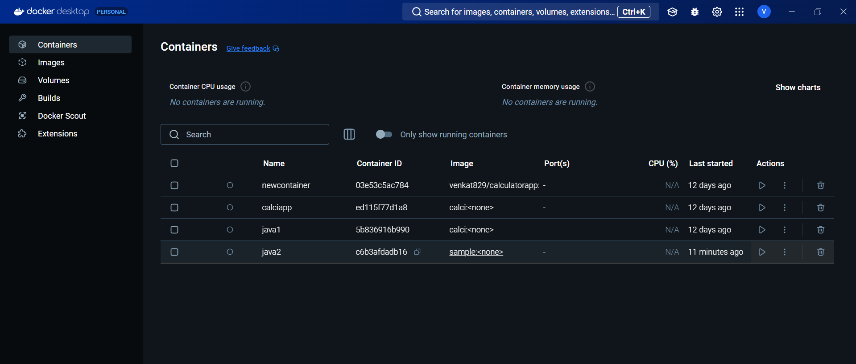

Successful Dockerized the Application :

